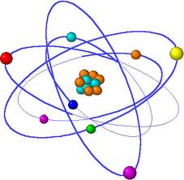
Directions: Democritus, J. Dalton, J.J. Thomson, E Rutherford, N. Bohr, and E. Schrodinger all made large contributions to the current model of the atom; your job is to create a timeline displaying that. You are to research each scientist above (6 total) and describe their discoveries. You will need the following: Scientist name, year, his discovery, why his discovery was significant, and any additional information that may have any significance. Also, if necessary, include how scientists improved upon other scientists ideas. You may use any online sources except Wikipedia.
Atomic Theory Timeline
400 B.C. | 1600 | 1650 | 1700 | 1750 | 1850 | 1900 | 1950
200dfadf2000200

