EXTRA CREDIT: MOLECULAR STRUCTURE
The Assignment
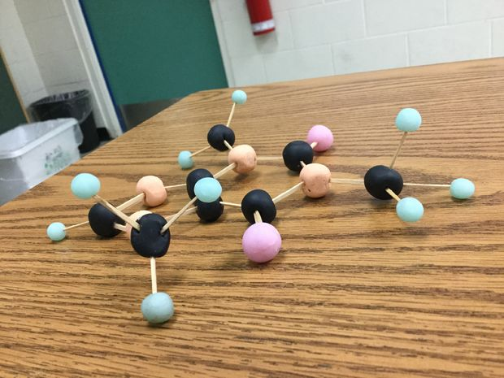
- You will have the opportunity to at any time during the year to complete an extra credit opportunity. It will be to create a realistic model of a molecule.
- The molecule signup sheet is posted on the classroom webpage (Shull-Science.weebly.com). No molecule may be duplicated
- The molecule must be made of the following components:
  - Styrofoam balls for the individual atoms
  - Wood sticks for the bonds
  - There are no substitutions
- The Styrofoam balls should be color coordinated and roughly all the correct size aim for around a 1 inch diameter. (If you have a hydrogen, they all need to be the same size – you do not actually need to measure anything out)
- The molecule must have correct bond angles and orientation. If you are unclear as to what that means, ask first.

Grading
- 10 possible extra credit points (not counting toward mole dollar limits)
- 3 point for correct bond angles
- 3 points for correct orientation
- 2 points for the correct atoms
- 2 points for presentation
  - It should not fall apart; these will be hanging from the ceiling for the duration of the year.

