Name _________________________ Date ______________ Period _________

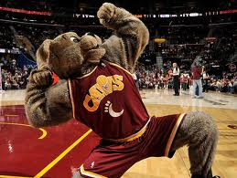
Physics - Projectile Motion Practice (Round 2) – Unequal elevation

1. Moon dog is in the Quicken Loans Arena rafters (75m high) shooting Cavalier T Shirts to screaming Cavs fans. If Moon dog shoots the T Shirts at a 35⁰ angle and with a velocity of 25 m/s

a. How long will the shirt be in the air?

b. What is the final vertical velocity?

c. What horizontal distance will the arrow travel?

2. Moon Dog is performing during the Cavalier halftime show. Moon dog jumps onto a mini trampoline and a flaming hoop. If the trampoline is 1.5 meters in the air, and he leaves the trampoline at 15 m/s at a 50⁰ angle:

- How far away does the safety crew need to place device to catch Moon Dog

